
PT. SINKO PRIMA ALLOY
Alamat : Jl. Tambak Osowilangun Permai No. 61,
pergudangan osowilangun permai Blok E7-E8,
Surabaya-Indonesia (60191)
Telepon : 031-7482816
Fax. : 031-7482815
Aftersale (WA) : 0821-4281-7085
Email : aftersales@elitech.co.id
sinkoprima@gmail.com
Website : www.elitech.id

SPA-BM/PROD-31. 15 Oktober 2024. Rev04

Instructions to User
Dear users, thank you very much for purchasing the SPIROMETER.
Please read the User Manual carefully before using this product. The User Manual which describes the operating procedures should be followed strictly. Failure to follow the User Manual may cause measuring abnormality, equipment damage and human injury. The manufacturer is NOT responsible for the safety, reliability and performance issues and any monitoring abnormality, human injury and equipment damage due to users' negligence of the operation instructions. The manufacturer’s warranty service does not cover such faults.
Owing to the forthcoming renovation, the specific products you received may not be totally in accordance with the description of this User Manual. We would sincerely regret for that.
This product is medical device, which can be used repeatedly.
WARNING:
- For accuracy, it is recommended that the SPIROMETER should not be tested on the same testee for more than 5 times.
- The testee should breathe out all air during testing, don't exchange air or cough.
- Don't use the device in environment with lower temperature.
- Automatic power off when there is no operation in one minute.
- Please refer to the correlative literature about the clinical restrictions and caution.
- This device is not intended for treatment.

The User Manual is published by our company.All rights reserved.

Contents
Chapter 1 Safety 1
1.1 Instructions for Safe Operations 1
1.2 Warning 1
1.3 Attention 2
Chapter 2 Overview 3
2.1 Features 3
2.2 Major Applications and Scope 4
2.3 Environment Requirements 4
Chapter 3 Principle 4
Chapter 4 Technical Specifications 5
4.1 Main Performance 5
4.2 Main Parameters 5
Chapter 5 Installation 6
5.1 View of the Front Panel 6
5.2 Installation 7
5.3 Accessories 7
Chapter 6 Operating Guide 7
6.1 Application Method 7
6.1.1 Installation 7
6.1.2 Measurement 7
6.1.3 Parameter Interface 8
6.1.4 Menu Operations 9
6.1.5 Repeated Measure 15
6.1.6 Charge 16
6.1.7 Upload Data 16
6.2 Attention 17
Chapter 7 Maintain, Transportation and Storage 17
7.1 Cleaning and Disinfection 17
7.2 Maintain 18
7.3 Transportation and Storage 18
Chapter 8 Troubleshooting 18
Chapter 9 Key of Symbols 20
Chapter 10 Parameter Introduction 21

Chapter 1 Safety

1.1 Instructions for Safe Operations
- Check the main unit and all accessories periodically to make sure that there is no visible damage that may affect patient’s safety and monitoring performance. It is recommended that the device should be inspected weekly at least. When there is obvious damage, stop using the device.
- Necessary maintenance must be performed by qualified service engineers ONLY. Users are not permitted to maintain it by themselves.
- The SPIROMETER can not be used together with devices not specified in User Manual. Only the accessory that is appointed or recommendatory by manufacture can be used with this device.
- This product has been calibrated before leaving factory.

1.2 Warning
- Please don't measure this device with functional tester for the device's related information.
- Explosive hazard—DO NOT use the SPIROMETER in the environment with tinder such as anesthetic.
- Please check the packing before use to make sure the device and accessories are totally in accordance with the packing list,or else the device may have the possibility of working abnormally.
- Don't use the device in environment with strong electromagnetic interference, direct breeze source, cold source and hot source.
- Portable or mobile RF equipment with strong electromagnetic interference may influence the accuracy of this device.
- The disposal of scrap instrument and its accessories and packing (including mouthpiece, plastic bags, foams and paper boxes) should follow the local laws and regulations.
- Please choose the accessories which are appointed or recommended by the manufacturer for avoiding device damage.
- Don't use the device with the turbine of the same kind product.

1.3 Attention
    - Keep the SPIROMETER away from dust, vibration, corrosive substances, tinder, high temperature and moisture.
    - If the SPIROMETER gets wet, please stop operation.
    - When it is carried from cold environment to warm or humid environment, please do not use it immediately.
    - DO NOT operate button on front panel with sharp things.
    - High temperature or high pressure steam disinfection to the device is not permitted. Refer to User Manual in the relative chapter (7.1) for cleaning and disinfection.
    - Do not have the SPIROMETER immerged in liquid. When it needs cleaning, please wipe its surface with medical alcohol by soft material. Do not spray any liquid on the device directly.
    - When cleaning the device with water, the temperature should be lower than 60℃.
    - The display period of data is less than 5 seconds, which is changeable according to the end rate.
    - When data can't be displayed at all times or other cases happened during testing, press "repeated measure" key to remeasure, or power off to restart.
    - The device has normal life for three years since the first electrified use.
    - When the data goes beyond the limits, the main screen shows "Error!".
    - The device doesn't suit all users, if you can't get good measurement data, please stop using it.
    - The device needs to be calibrated once per year or less.
    - The device is forced SPIROMETER, according to the user manual to use right to gain best result.
EMC declaration:
    - When this device is installed or putted into service, EMC should be paid more attention, as the portable and mobile RF communications equipment with higher EM interference can affect this device.
    - The internal components and cables should not be changed, as this may decreased IMMUNITY of the device.
    - The SPIROMETER should not be used adjacent to or stacked with other equipments.

Chapter 2 Overview
Forced Vital Capacity is the max expiration after taking a full breath, it's an important examination content in chest-lung disease and respiratory health, and it is indispensable testing project in modern Pulmonary inspection. At the same time, it has great significance in respiratory diseases, differential diagnosis, treatment evaluation and selection of surgical indications. Thus, with the rapid development of clinical respiratory physiology, clinical applications of lung capacity inspection are also gaining popularity.
The SPIROMETER is small in volume, low in power consumption, convenient in operation and portable. With high-definition display screen, the device is concise and fashion. It is only necessary for patient to breath in fully and seal the lips around the mouthpiece and blast the air out in best times for measure, then the display screen will directly show the Forced Vital Capacity(FVC), Forced Expired Volume in one second (FEV1), Peak Expiratory Flow (PEF) with the high veracity and repetition.

2.1 Features
- Ultra-thin design, concise and fashion.
- Small in volume, light in weight and convenient in carrying.
- Low power consumption.
- TFT display.
- Reflect lung function by measuring FVC, FEV1, PEF etc.

2.2 Major Applications and Scope
The SPIROMETER is a hand-held equipment for examining lung function. The product is fit for hospital, clinique, family for ordinary test. It's requested that the user operates it according to user manual, doesn't need carry on specialized training, so the operation of the device would be as simple and easy as possible.

2.3 Environment Requirements
Storage Environment:
Temperature: -10℃~+55℃
Relative humidity: ≤95% RH
Atmospheric pressure: 500 hPa ~ 1060 hPa
Operating Environment:
Temperature: +18℃ ~ +30℃
Relative humidity: 10% RH ~ 85% RH
Atmospheric pressure: 700 hPa~1060 hPa

Chapter 3 Principle
Firstly, testee deep inspires, then seals the lips around the mouthpiece and blasts all air out as forcefully as possible, the exhalant gas transforms to rotary airflow by turbine, then makes the blade rotate. The reception part of the infrared pair diodes (one is for infrared emission, the other is reception) towards to the blade is used for receiving the infrared ray, when the blade rotates, the received ray strength of the reception diode will be different as the difference of the blade angle, so form the various signal of same proportion in reception diode, which forms acquisition signal by SCM after processing. At last, various parameters to be measured formed from the information which were processed by the microprocessor, and displayed from the screen.

Chapter 4 Technical Specifications

4.1 Main Performance
- Forced Vital Capacity (FVC), Forced Expired Volume in one second (FEV1), the ratio of FEV1 and FVC (FEV1%), Peak expiratory flow (PEF), 25% flow of the FVC (FEF25), 75% flow of the FVC (FEF75) and average flow between 25% and 75% of the FVC (FEF2575) can be measured.Besides, the testee condition can be shown by the ratio of the measured value and the predicted value.
- Flow rate-volume chart, volume-time chart display.
- Data memory, delete, upload and review.
- Trend chart display.
- Scalering (Calibration).
- Information prompts when volume or flow goes beyond the limits.
- Automatic power off when there is no operation in one minute.
- Rechargeable lithium battery and with charging tips.
- Battery power display.

4.2 Main Parameters
Max volume: 10L
Flow range: 1 L/s ~16 L/s
Volume accuracy: ±3% or 0.05L (whichever is greater)
Flow accuracy: ±10% or 0.3L/s (whichever is greater)
The highest resistance to flow within the measurement is 6Pa/L/s, and this resistance may be occur at 14L/s.
Power Adapter: DC 5V
Input Power: ≤ 3VA
Battery: Li-ion Polymer Battery 3.7 V 550 mAh
Weight: 99 g
Dimension: 95 mm (L) x 89 mm (W) x 36 mm (H)
Classification:
EMC: Group I Class B.
According to the MDD 93/42, the classification of this medical device: Ⅱa
The type of protection against electroshock: Internally powered equipment.
The degree of protection against electroshock: Type BF applied part.
The degree of protection against ingress of water: IPX0.

Chapter 5 Installation

5.1 View of the Front Panel
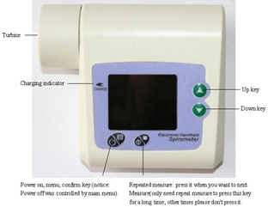
Fig.1 Front panel view

5.2 Installation
- Hold the turbine, make the arrowhead of the turbine to the triangular shape on the shell, gently insert into the bottom, counterclockwise rotate to lock it.
- Insert the disposable mouthpiece into the turbine port.

5.3 Accessories
- An User Manual
- An USB data line
- Disposable mouthpiece
- A power adapter (optional)
- A CD (PC software)
- A nose clip (optional)
Other type adapter should meet the following conditions: output voltage: DC 5V; output current≥500mA, the power adapter must meet the requirements of EN60601 related standards and have the CE mark.

Chapter 6 Operating Guide

6.1 Application Method

6.1.1 Installation
Hold the turbine, make the arrowhead of the turbine to the triangular shape on the shell, gently insert into the bottom, counterclockwise rotate to lock it,then insert the disposable mouthpiece directly into the turbine port.

6.1.2 Measurement
- Long press "power on" key to turn on the power after installed.
- The device is in selective interface after turn on as Fig.2, press "up", "down" key to adjust, select "No" to "Testing" interface as Fig.3.
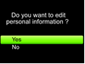  Fig.2 | 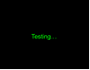  Fig.3
- Then breath in fully and seal the lips around the mouthpiece and blast all air out as forcefully as possible in best times, wait for a few seconds,then the data will be gained, measure is over (Note: "Yes" indicates that you can edit patient information, exit after edit, or return to "Testing" interface, the detail operations are as following).

6.1.3 Parameter Interface
In testing interface, breath in fully and seal the lips around the mouthpiece and blast all air out as forcefully as possible in best times, wait for a few seconds, then the measured parameter will pop up automatically as Fig.4.
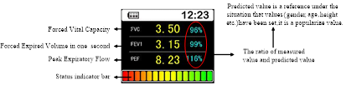
Fig.4
(Note: Status indicator bar: indicate the measured state, display the testee condition by the ratio of measured value and the predicted value. I.e. Compared the measured value with the reference value in same situation, when the value is lower than 50% indicates that should be noticed and hospitalized in time; The value in range from 50%-80% indicates that should be noticed; it is green when the value is higher than 80%, which is normal. The state value is optional, press "Control Setting" in main menu,t hen press "Denote Value" to select.)
Flow rate-volume chart, volume-time chart: press "up", "down" key will appear two charts: Flow rate-volume chart, volume-time chart (as Fig.5, 6). The above three interfaces are main interface, in its interface, press "Menu" to main menu as Fig.7.
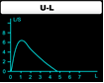  Fig.5 Flow rate-volume chart | 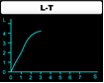  Fig.6 Volume-time chart

6.1.4 Menu Operations
When testing, press "Menu" to its main-menu as Fig.7, then user can browse other parameters, and control setting, patient information, real time setting, power off, etc. can be operated, the detail methods are as following:
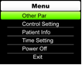
Fig.7
- Other parameters
Press "Other Par" in main menu to its sub-menu as Fig.8 which displays other parameters except for the three parameters in main menu (see following as details), press confirm key to return to the main menu (press "up", "down" key in this interface is no effect).
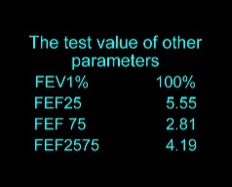
Fig.8
- Control setting
Press "Control Setting" in main menu interface to its sub-menu as Fig.9, then the relative operations can be done.
- Trend curve
Select "Trend Curve" to the determinant interface of trend curve as Fig.10. Press "up" or "down" key to select the determinant value, then press the confirm key to display the variational trend visually, which is convenient for user to contrast the data. If the data is too much, then press "up" or "down" key in curve interface to browse all data trend curves orderly. Press the confirm key to exit the current interface, return to the control setting interface(as Fig.9).
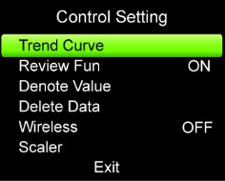
Fig.9
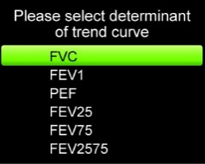  Fig.10 | 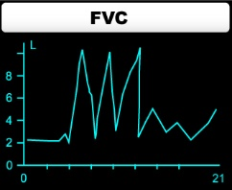  Fig.11
- Review information
Select "Review Fun" to its sub-menu. If the previous display state is "OFF", then press the confirm key to open the function (Note: the review function only can be opened when the case numbers are more than one), then the interface will jump to Number interface as shown in Fig.12. In this interface, use the "up" or "down" key to select the case number, then press the confirm key to review the selected case information. If the previous display is "ON", then press the confirm key to jump to previous state (namely: If the measurement has been completed before reviewing, then close this function, display "OFF" state, or jump to the measurement interface as Fig.2 shown).

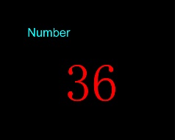
Fig.12
Attention: Open the review function can browse all measured data,the path is: Enter the main menu as Fig.7, select "Patient Info", press the confirm key to enter its sub-menu as Fig.21. Select "Number", then press the confirm key to case number interface as Fig.12 (the function only can be selected in case of opening the review function), then use "up" or "down" key to select case number, press the confirm key to browse the corresponding information. If you want to browse other cases, then repeat the above steps (If the case data is error, then it will display "Error!" after pressing the confirm key).
- Denote value
Select "Denote Value" to its sub-menu as Fig.14, press confirm key to choose which one to decide the denote value (as Fig.14, the denote value is decided by the ratio of FVC and average value), after selected, press confirm key to exit the interface( Note: the state value is a percentum which was decided by the ratio of measured value and predicted value).
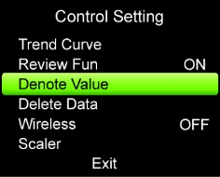  Fig.13 | 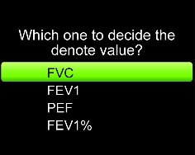  Fig.14

- Wireless transmission
If the device has built-in wireless module, then it can open and close the wireless module when select "Wireless", when opens, it can transmit data, the operation is noneffective for the device which has not built-in wireless module.
- Scaler operation(Calibration)
Select "Scaler(Calibration)" to its sub-menu as Fig.17, then the Scaler(Calibration) volume can be selected, after selected the volume, it will enter Scaler(Calibration) interface as Fig.18. In this interface, when moving the scaler once, the interface will display "REPEAT", then move the scaler continuously. After twice right scaler (Calibration) operation, the scaler (Calibration) is successful, then the interface will display "OK!". Finally the interface will jump to the former interface before scalering(Calibration). If Fig.19 appears, it indicates the scaler(Calibration) is error, then repeat scalering(Calibration) until succeeding. If Fig.20 appears, then confirm the volume between scaler (Calibration) and selected is accordant, then scalering(Calibrate) until succeeding. If you need to stop scalering (Calibration), only press the confirm key to exit the former interface before scalering (Calibration). (the interface before scalering (Calibration) refer to: If scalering (Calibrate) after completing measuring, then it will exit to the control setting interface, otherwise jump to the measurement interface as Fig.2).
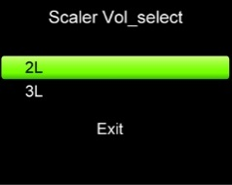  Fig.17 | 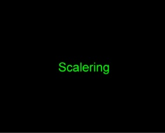  Fig.18
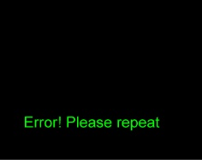  Fig.19 | 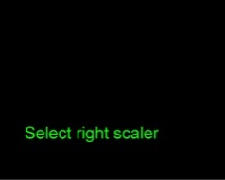  Fig.20
- Exit
Select "Exit" to exit "Control Setting" interface and return to the main menu.
- Patient information
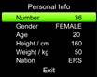
Press "Patient Info" to its sub-menu as Fig.21 (Note: Fig.2 is selective interface, and if "Yes" indicates that you can edit patient information).

Fig.21
- Number
"Number" is the current patient data.
Attention: If the review function is open, press the confirm key to case number interface to review patient's information, refer to "Review Information" in Section 6.1.4 for the detailed operations.
- Gender settings
Press "up", "down" key to "Gender", short press keystroke to select "FEMALE" or "MALE".
- Patient information settings (age, height, weight and nation)
Press "up", "down" key in patient information interface to "Age", press "Menu" to "adjust age" interface, press "up", "down" key to adjust age, press once "up" or "down" key means that the number is ascended or descended once, till to the ideal value,then press "Menu" to "Patient Info" interface. The operations of adjusting "Height", "Weight", "Nation" are same with "Age". The range of "Age" is 6~100, "Height" is 60~240cm, "Weight" is 15~250kg, select "Nation" according to predicted standard, including "ERS, KNUDSON, USA".
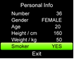  Fig.22 | 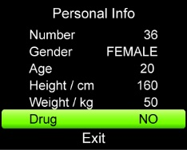  Fig.23
- Smoker, drug option
Press "up", "down" key in patient information interface to "Nation", press "down" key, then "Smoker" appeared, if continuously pressing "down" key, "Drug" appeared, then press confirm key, you can select "Yes" or "No" to "Smoker" or "Drug" to edit.
- Exit
Press "up", "down" key to "Exit" to exit "Patient Info" interface and return to the main menu.
- Power off
Press "Power Off" to turn off the device.
- Exit the main menu
In the main menu interface, press "Exit" to exit the main interface.

6.1.5 Repeated Measure
Long press "repeated measure" key for no more than 3 seconds can start a new test, but the following information as Fig.24 will appear when the memory is full, press "up", "down" key to set, select "Yes" to "Delete Data" interface, when selecting it, after deleting data, exit to main interface to continue measure. "No" to main menu.

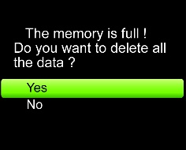

Fig.24

6.1.6 Charge
There are two kinds of charging methods:
- Connect the device with computer by data line― then the device should be under charging state.
- Connect the device with power supply by power adapter, then the device should be under charging state.
DO NOT use the machine when it is under charging state with this power adapter.
The red and green indicators are all highlight in charging state, the red indicator goes out when the charge has finished.

6.1.7 Upload Data
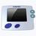
Install the PC software in the computer, then the following figure will appear after completing.

Fig.25

- Connect the device with computer by data line,double press the icon to open the PC software procedure.
- Press the corresponding key to achieve upload data,delete case,print information, background, select language, switch PDF format, set the testee information etc.
- Press "exit" to exit the software, unplug the data line from the computer to achieve uploading.

6.2 Attention
    - Please check the device before using, and confirm that it can work normally.
    - Rechargeable lithium battery.
    - It is recommended that the device should be measured in room.
    - Excessive ambient light may affect measurement accuracy. It includes fluorescent lamp, dual ruby light, infrared heater, direct sunlight etc.
    - Intense activity of the subject or extreme electrosurgical interference may also affect the accuracy.
    - Please clean and disinfect the device after using according to the User Manual (7.1).

Chapter 7 Maintain, Transportation and Storage

7.1 Cleaning and Disinfection
Using medical alcohol to wipe the device for disinfecting,nature dry or clean it with clean soft cloth. It's necessary to clean the turbine periodically for accuracy, keep the diaphaneity of the lucency part, and keep it away sundries (such as hair or lesser sediment). Immerse the turbine in detergent solution after use, clean it with clean water and dry standing vertically after soaked a few minutes (but don't make the turbine rinsed with water directly), this type doesn't bring pollution to environment. (Note: The disinfectant is 75% alcohol).

7.2 Maintain
- Please clean and disinfect the device before using according to the User Manual (7.1).
- Please recharge the battery when the screen shows low-power (the battery power is ).
- Recharge the battery soon after the over-discharge. The device should be recharged every six months when it is not regular used. It can extend the battery life following this guidance.
- The device needs to be calibrated once a year (or according to the calibrating program of
hospital). It also can be performed at the state-appointed agent or just contact us for calibration.

Transportation and Storage
- The packed device can be transported by ordinary conveyance or according to transport contract. The device can not be transported mixed with toxic, harmful, corrosive material.
- The packed device should be stored in room with no corrosive gases and good ventilation.
Temperature: -40°C~55°C; Relative Humidity: ≤95%.

Chapter 8 Troubleshooting
Trouble | Possible Reason | Solution
The device can't finish measurement for a long time,and the data can't be displayed. | The start speed is too low,the device does not measure. | Remeasure according to the user manual.
 | The malfunction of the device. | Press "repeated measure" key to remeasure,or power off to restart.
The figure is wrong and unorderly. | The power turned off abnormally. | Delete the current case and remeasure.
The figure is wrong and unorderly. | Operation is wrong. | Operate normally according to the user manual.
The figure is wrong and unorderly. | The malfunction of the device. | Please contact the local service center.
The device can not be powered on. | The battery is drained away or almost drained away. | Please charge up battery.
The device can not be powered on. | The malfunction of the device. | Please contact the local service center.
The display disappears suddenly. | The device is set to automatic power off when there is no operation in one minute. | Normal.
The display disappears suddenly. | The battery is drained away or almost drained away. | Please charge up battery.
The device can not be used for full time after charge. | The battery is not full charged. | Please recharge the battery.
The device can not be used for full time after charge. | The battery is broken. | Please contact the local service center.
The battery can not be full charged even after 10 hours charging time. | The battery is broken. | Please contact the local service center.

Chapter 9 Key of Symbols
Symbol | Meanings
 | Refer to instruction manual/booklet.
 | Hazard or Warning - pay close attention.
 | WEEE (2002/96/EC).
 | Type BF Applied part.
 | Full-power.
 | Low-power.
Error | Measured value goes beyond the limits.
 | DO NOT REUSE.
 | Status indicator bar.
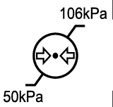 | Atmospheric pressure limitation.
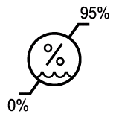 | Humidity limitation.
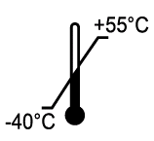 | Temperature limitation.
 | Fragile,handle with care.
 | Keep away from rain.
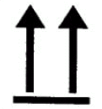 | This way up.
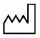 | Date of manufacture.
 | Manufacturer.
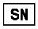 | Serial number.

Chapter 10 Parameter Introduction
Measured parameters
Parameter | Description | Unit
FVC | Forced vital capacity | L
FEV1 | Forced Expired Volume in one second | L
PEF | Peak expiratory flow | L/s
FEV1% | FEV1/FVC×100 | %
FEF25 | 25% flow of the FVC | L/s
FEF2575 | Average flow between 25% and 75% of the FVC | L/s
FEF75 | 75% flow of the FVC | L/s

DIGITAL SPIROMETER
SP-10

MANUAL BOOK



